California State University, Northridge

Department of Electrical & Computer Engineering



ECE 526L

Lab 6 Report

By

Avinash Damse

CSUN ID- 203131064

**1: Introduction**

The objective of this lab is to build Verilog model for a scalable multiplexer using behavioral Verilog and Familiarization with instance-by-instance parameter specification.

Here we have to use following diagram to build scalable multiplexer.

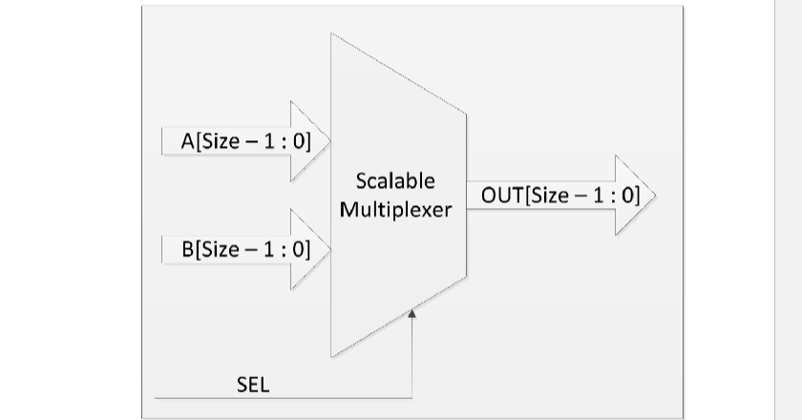

**2: Procedure**

**a. Part 1: Creating mux Module**

In this lab I have created a mux module for scalable multiplexer. Inside the module I have assigned “A, B and SEL,” as input variables and “OUT” as output variables. Then I wrote the scalable multiplexter logic inside module. After completing the code I ended the module using and saved the file with name “mux.v”.

**b. Part 2: Creating mux_tb Module**

I have written the test bench for the mux module.We require test bench just to make sure that the module we have created is working properly. Here, in this testbench I instantiated the mux module and wrote some test cases to check the output.

**c. Part 3: execution.**

Using “vcs -debug -full64 mux.v mux_tb.v” command I executed the file.

**d. Part 4: Simulation**

After an execution of all modules, I have run the command “simv” for simulation.

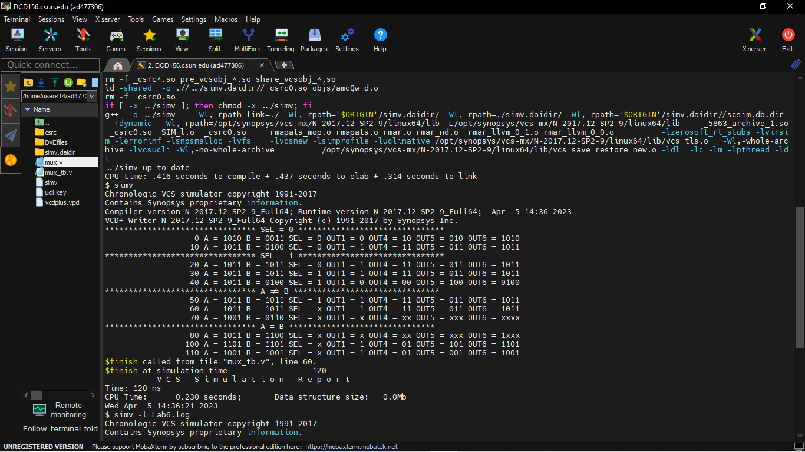

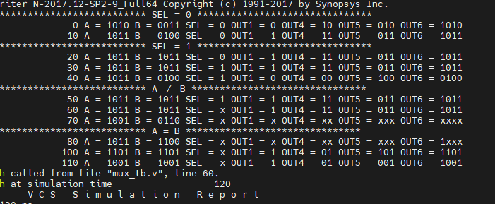

**e. Part 5: Creating Log File**

After running the simulation I created the log file using the “simv -l Lab6.log” command.

**f. Part 6: Seeing the waveform.**

After creating the log file I opened the DVE using “dve -full64 &” command to see the waveforms.

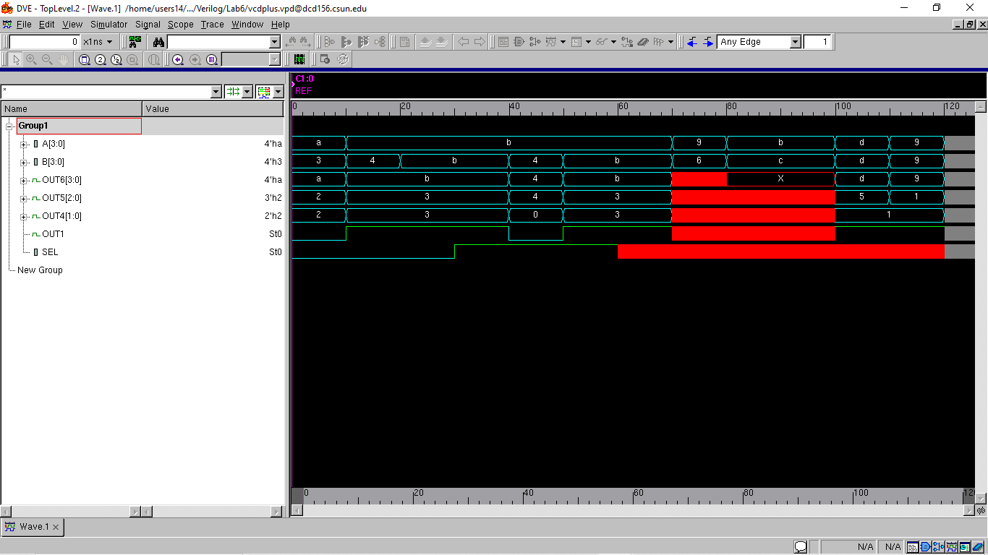

**Conclusion:**

The functionality of the scalable multiplexer coded in this lab was successfully verified. In addition to the normal features of a multiplexer, it has the capability to resolve conflicting bits upon setting SEL to x. The instances were also successfully created with the parameters modified according to specification.

I hereby attest that this lab report is entirely my own work. I have not copied either code or text from anyone, nor have I allowed or will I allow anyone to copy my work.

Name (printed) Avinash Damse

Name(signed) Date : 5-April-2023

